Study of the consequences of two cold weather periods on the 2020 Swift breeding season at Gledhow, Leeds in particular, and the Swift breeding season in general.

Introduction
The 2020 Swift Season at the Gledhow colony in Leeds was as fascinating as ever, but breeding success was very disappointing. Some pairs did well, but others struggled, particularly in two spells of cold weather of early June and then July.
Gledhow is situated in suburban North Leeds, with plenty of woodland nearby and a couple of relatively small water bodies close enough for Swifts to take advantage of. In inclement weather, hundreds of Swifts can gather at areas such as St. Aidan’s nature reserve, in the Aire valley, 10 miles away. The Aire Valley is a magnet for feeding birds, but may have limited resources for hundreds of hungry Swifts in a prolonged cold spell.
In 2012, the Gledhow Swift colony consisted of three pairs of Swifts nesting in natural nests in roof spaces on just two houses in the same street. With the gradual provision of nest boxes and call players on twelve houses, this one street colony has expanded yearly and this Summer there were 21 breeding pairs. They were joined by seven pairs of non-breeders this year. Some of the boxes have cameras and are monitored by the houseowners.
Thirteen of the breeding pairs are on two houses and are monitored by cameras, and they were joined by four non-breeding pairs this Summer. See Table 10 for breeding success in the last six years from this fully monitored part of the colony.
In this study, the definition of a successful egg is a fledged Swift.
In 2020, 34 eggs were laid by these 13 pairs, but from these eggs, only 19 Swifts fledged. This is a success rate of just 56%, compared to the average percentage of successful eggs over the last six years of 82.2%. For comparison, in 2019, 12 pairs laid 29 eggs and 25 chicks fledged, a success rate of 86%.
The 13 pairs provided the breeding data for the study and the non-breeding pairs almost certainly contributed to our understanding of Swift weather movements.

Acknowledgements
Initially, the intention was to write a short study about a couple of pairs of Swifts at the Gledhow colony. However, the project started to develop as the research into the severity of the weather progressed. Not being a seasoned researcher meant that I have been grateful for data, advice and comments from various folk to make some sense of my findings.
In no particular order, thank you to:
Linda Jenkinson, Leeds Swifts and Start Birding birdwatching classes https://www.startbirding.co.uk/.
Jonathan Pomroy, Wildlife Artist and Swift/House Martin Afficionado.
Louise Bentley, Bury and Bolton Swifts.
Amy Calvert, Historian and Teacher.
Liam Calvert, Script Writer and Film Maker.
Zoë Calvert, Linguist and Teacher.
Mark Glanville, Bristol Swifts.
Simon Evans, Ornithologist and Swift Expert.
Dick Newell, Action for Swifts and Swift Guru.
George Candelin, Keeper of the Swifts, Oxford University, Museum of Natural History.
Bernard Genton, Swift Expert and author of “Martinet Noir: Entre Ciel et Pierre.”
Enric Fusté, wildlife carer at Aiguamolls/Torreferrusa Wildlife Rescue Centre (also www.falciotnegre.com).

Content.
1. Aims and Methodology.
2. Swift behaviour at the Gledhow colony in the first cold weather period 3rd-12th June. See Tables 1-3 in the appendix.
3. The detailed behaviour of two pairs of Swifts during the second period of prolonged cold weather 28th June-11th July. See Tables 4-6 in the appendix.
4. Swift weather movements.
5. Grounded Swift chicks.
6. Comparisons with colonies in Bristol, Oxford and Bury St. Edmunds in the first cold weather period. See Table 7 in the appendix.
7. Comparisons with colonies in Bristol, Oxford and Bury St. Edmunds in the second cold weather period. See Tables 8 and 9 in the appendix.
8. Other factors influencing breeding success.
9. Conclusions.

1. Aims and Methodology
The initial intention of this research was simply to try to explain the poor breeding performance at the Gledhow Swift colony. However, once the weather and temperatures for Leeds were studied, along with the large weather movement of Swifts in late June, it was a natural progression to also consider breeding success elsewhere, by examining weather conditions and breeding reports from three other locations.
It is known that Swift eggs and chicks can withstand being left unattended for some periods of time without lasting harm to the embryos or the chicks. This year, many clutches of eggs were left unattended for long periods. This study aims to link the external temperature and weather conditions to these periods of absence and then the eventual success or failure of the clutches of eggs. By using data from video recordings and diary entries, it is possible to find out when and for how long the Swifts were absent from their eggs. From this it might be possible to find out how long eggs can be left unincubated over the full period of incubation, without jeopardising the health of the chicks therein. Following on from this, it might be possible to find out if there is a critical average temperature, below which Swifts struggle to survive and breed.
This behaviour of the Swifts in neglecting their eggs in the cold weather periods has not been seen at this colony to any extent before, so it was an opportunity to study the conditions that led to such actions. Normally, clutches of Swift eggs are incubated constantly with the pair taking it in turn to incubate the eggs. It is often the case that the sitting bird is reluctant to leave and has to be encouraged by its partner to do so. Not so at Gledhow this season!
There are various reasons for eggs not being successful, such as deliberate ejection, accidental ejection, immature Swifts producing infertile eggs, chick mortality and weather conditions. Every year, some eggs are lost due to partners arriving late with the ensuing paternity issues and sometimes eggs are laid by an immature pair, so the success rate varies a little from year to year, but this year, there was an alarming decrease in success. The main reason for this seems to have been poor weather in 2 significant periods. These weather periods produced consistently low temperatures, especially in the North of England, below the seasonal average. In these periods, it appeared that the Gledhow Swifts experienced days of surviving at temperatures that were not conducive to producing enough insects to meet their needs.

2. First Cold Weather Period at Gledhow, June 3rd-12th
April and May had been settled with plenty of warm weather, then in early June, low pressure began to dominate and temperatures well below the average ensued for a period of 10 days. Northern and Eastern England felt the brunt of this spell. The following Met Office description of June’s weather covers both cold spells, the first at the start of the month and the onset of the second in the last week.
The Met Office description of the weather in June 2020
“The very sunny and warm weather of late May continued into the start of June, but a cool northerly type became established from the 3rd to 7th, bringing showers and some longer spells of rain. After a brief settled interlude, it turned wet almost everywhere by the 10th. Around mid-month there was a spell of warm, humid, showery weather with thunderstorms especially in central, western and southern areas, and persistent low cloud along the northeast coast. There was a hot sunny spell especially over England from the 23rd to 25th, which triggered a thundery breakdown in places. The last few days were cloudy and windy with showers and longer spells of rain, with especially persistent and heavy rain in parts of Cumbria.”
Figure 1 shows the UK temperature and pressure chart for June 6th 2020.

Figure 1. UK pressure and temperature chart for June 6th 2020, in the middle of this spell.
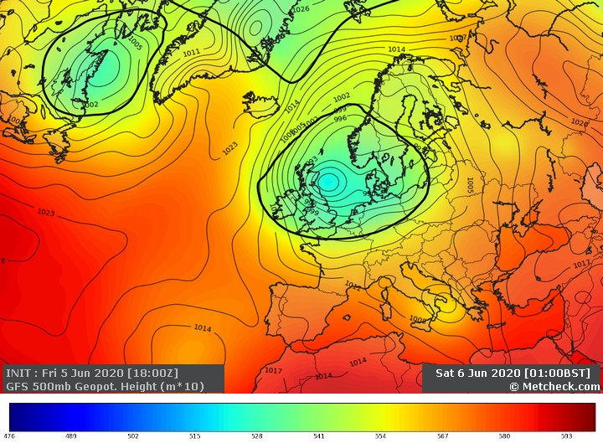
At the start of this cold weather period, three pairs had not yet produced eggs, four pairs were coming to the end of their incubations, one pair in box 3 were 10 days into their incubation period and there were five pairs in boxes 8, 11, 12, 14 and 15, just completing their egg laying. The first chicks hatched from 8/06, towards the end of this cold weather spell. Had they hatched a few days earlier, they may not have survived. The 5 pairs in 8, 11, 12, 14 and 15 only started their incubations from around the June 3rd-5th. Strangely, they had all laid their first eggs on June 1st! All these pairs left their eggs unattended for long periods, concentrated over just 7 days from 6/06-12/06. Table 1 shows some of the absences over the first period, taken from Gledhow diary records. Four of the pairs listed in Table 1 went on to rear chicks successfully, whilst 2 pairs failed. One of these failed pairs, in box 12, kept on incubating until finally giving up in the middle of the second cold spell on July 2nd. They incubated for 27 days, much longer than the usual 20-day period. An attempt to make up for long periods of absence? They were an experienced pair. The other failed pair in box 14 were particularly unfortunate, having their first clutch stolen by a female House Sparrow on June 6th, in this cold period, before being unsuccessful with their replacement clutch at the end of the second cold weather period.
In this first period, there were some lengthy periods of absence from the eggs, the longest single absence of an eventually successful pair being the 438 minutes from Box 8 on June 7th. However, the total amounts of time that the eggs were not incubated over the 6 days didn’t stop the pairs in boxes 3,8,11 and 15 going on to rear their chicks successfully. From Table 2, it can be seen that the Swift eggs in box 8 were left unincubated for nearly 25 hours in total over the 20/21-day incubation period. This equates to 71 minutes a day, yet they still produced healthy chicks. However, the pair in box 12 that suffered both cold weather periods during their incubation, were absent for nearly 47 hours in total, equating to over 2 hours a day over the total incubation period and their eggs failed to hatch. After they had given up, one of their eggs containing a well grown embryo, ended up on the floor under the nest box.
From Table 2, therefore, it can be seen that the maximum amount of time that eggs can be left unattended and still be successful is between 71 minutes (box 8) and 134 minutes (box 12) per day. The relation between amounts of time eggs can be left unattended and breeding success is examined in further detail in the second cold weather period.
Also, late in this period, on June 8th, the first chicks hatched in the colony, but these too were left unattended on numerous occasions and with long gaps between feeds until fine weather returned.
Table 3 lists the daily temperatures and the average temperatures in Leeds in this period. From June 3rd-12th, the average was just 9.7 degrees, way below the June average of 14 degrees. This meant that Swifts were away for long periods searching for their insect prey, thus the normal, constant incubation of eggs was impossible as the sitting bird became hungry and often left long before its partner had returned. Had the Swifts not been absent for long periods, it is highly likely that the first clutch, of three eggs in box 14 would not have been stolen by a House Sparrow an hour or so before the return of one the occupying Swifts. However, this theft of eggs and the eventual failure of the eggs in box 12 are the only Gledhow losses directly attributable to this cold weather period.

3. Second cold weather period at Gledhow, June 28th-July 11th 2020
Before looking at the effects of the second cold spell on the Gledhow colony Swifts, it is relevant to look at the reaction of some of the non-breeding Swifts to the impending low-pressure system.

4. Swift Weather Movements
Swifts have an ability to sense impending deep low-pressure systems and as superb fliers, can easily fly round these depressions to temporarily relocate to areas that will continue to provide good insect supplies. Breeding Swifts usually stay and ride out the poor weather, but birds with no ties to a location can avoid the paucity of insect supplies that the low pressure might cause, by joining up with others and relocating. Looking at the U.K. temperature and pressure map in Figure 2, any Swifts wishing to avoid this system could well have flown to the nearest part of the continent, from the East coast, as a route to finding much better feeding conditions. It can be seen that the deep low-pressure system centred on Northern England, Ireland and Scotland.

Figure 2. UK pressure and temperature chart 28th June 2020
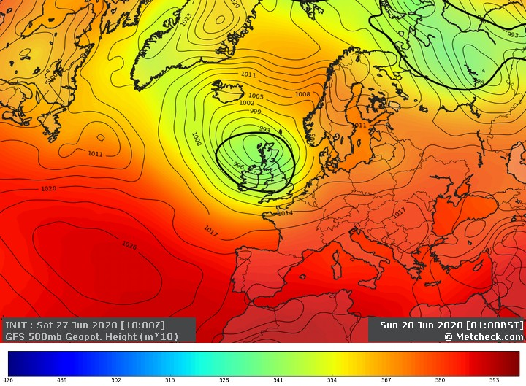
The imminent arrival of this deep low-pressure front was signalled by a ferocious thunderstorm on Friday 26th June, which was part of the weather system that introduced much colder air. There was a dramatic change in temperature and all the prospecting Swifts disappeared from the locality on the following day. Swifts are renowned for having the ability to sense and avoid weather fronts by relocating temporarily to a location with favourable weather and thus good supplies of insects. From the 27th to the 29th, www.birdguides.com featured lots of reports of Swifts heading south in Northumberland, East and North Yorkshire, Lincolnshire, Norfolk, Suffolk and Essex. These sightings from the Eastern side of the country from June 27th to 29th give us a likely explanation of where the missing Swifts had headed. Some of the counts are on www.trektellen.com with the highlights being over 6,000 through Spurn on the 27th and over 18,000 through at Hunmanby Gap on the 28th. Then the big day on Monday the 29th when huge counts of Swifts were recorded going south on the east coast, with a count of 45,844 birds recorded in the morning at Gibraltar Point, Lincolnshire. The description of this record breaking morning by Ben Ward is fascinating. On the same day there was a report on www.trektellen.com of a count of 35,048 Swifts at Dordtse Biesbosch, inland in Holland, up the estuary of the rivers Waal & Maas and another count of 31,805 on the following day from the same location. Were these counts coincidental? Probably not, as it is only a short flight for a Swift to reach the Netherlands from the East of England and looking at the weather chart, it would have been a wise option, but for now it is impossible to be sure.
The theory of the make-up of these huge numbers of roaming Swifts is that they consist mainly of second calendar year birds (2cy), i.e. birds that are one year old, but the following account may prove that not all the Swifts in these mass movements are second calendar year birds.
The prospecting birds returned from around July 11th and screaming parties re-commenced. Indeed, one Swift that had been roosting at the colony with a partner in box 10 since May 30th, disappeared on June 27th, only to reappear on July 11th. Without the birds being ringed or tagged, one can’t be 100% sure that the returning bird was indeed the original partner, but observation of the interaction at the “re-union” of the pair at 06.00 on the morning of the 27th strongly indicates they were already a couple. Also, the chance of a new bird finding that particular box so early on the first day of prospecting since June 26th is tiny, so backs up the theory of it being the returning bird.
It is generally agreed that Swifts migrate in waves. See page 62 in “Martinet Noir: Entre Ciel et Pierre” by Swift expert and author Bernard Genton for more details. With dates adjusted for England instead of Switzerland, the first wave of Swifts arrive from the end of April till nearly the end of May and consist of experienced breeders and birds that will lay eggs for the first time. The second wave overlaps with the first and consists of two and three-year olds who will become pre-breeders and bangers. They arrive towards the end of May up to late June, probably overlapping with the third wave. This final wave is made up of one year- olds who arrive towards the end of June and behave like bangers.
If it is correct, as seems highly likely, that the pair in box 10 separated for 2 weeks, before re-uniting, it is fascinating behaviour. This pair had been roosting together since May 30th, indicating that neither of them were second calendar year Swifts, according to the date they arrived at the colony. As per Bernard Genton’s Swift arrival waves, birds arriving May 30th should be either mature, ready to breed or pre-breeders, but certainly not one-year old Swifts.
From this and because they hadn’t laid any eggs, the assumption might be that at least one of them was a 3rd calendar year (3cy) or 4th calendar year (4cy) bird, not yet mature enough for breeding. As they had been roosting as a pair since May 30th, maybe the combination was a 2 year- old (c3y) and the other a 3 year- old (4cy), or older. This might explain the different decisions of the pair on sensing the imminent low-pressure system. Remember it is thought that these seemingly annual, mid-season weather movements are made up of young birds that fledged in the previous year. However, one of the pair, as explained, presumably not a second calendar year Swift, still felt the urge to avoid the impending deep low-pressure system and thus it joined the thousands of Swifts on the “Tour”, whilst its partner stayed and roosted on its own for fourteen nights. The greeting received by the returning Swift was fascinating to observe and they soon went into pair bonding mode.
The Swift that decided to go on the “European Tour”, probably didn’t communicate its intentions to its mate of 4 weeks, hence the “reception” it received on its return. From observations, it seems clear that a pair of Swifts don’t communicate all their intentions to each other. As an example of this, at the end of the season, one of the pair decides to migrate and the partner can be observed to be quite unsettled after coming in to roost to find its partner gone. This year, this behaviour was observed at one box in the Gledhow colony and the incoming lone bird only stayed for just under an hour, before it too left the nest box for the final time in 2020.
There were simultaneous reports from various Northern Swift colonies of the mass disappearance from the skies, of prospecting birds from the 27th and the mass return on July 11th. Colonies in Leeds, Bolton, Gilling East and Sedbergh all reported returning Swifts on Saturday the 11th and the re-commencement of screaming parties and “Bangers.” It was lovely to see the return of the prospecting Swifts after a two-week absence.
It is usually Swifts without parental ties that constitute these grand displacements, which occur on an annual basis, in response to deep low-pressure systems. It makes sense that Swifts with no responsibilities, in the path of such a front, react in this way, but what happened to prospecting Swifts further south, not as affected by the low pressure, in a more favourable climate? It’s highly likely that the grand movement did not include prospecting Swifts from some Southern counties, where average temperatures in many areas during this period were 3 or more degrees warmer than those in the North. Average temperatures in this period in Portsmouth were 15.3 degrees, Torquay 15.2, Weymouth 15.2 and interestingly Birmingham 15.0. After the massive movement of Swifts in late June, Alastair from Kingsteignton Swifts wrote in an e mail on July 3rd: “Kingsteignton I believe no real change in numbers of swifts. Screaming parties around the established sites but few flybys near my house now that I have a pair. Have had about 10 to 15 swifts feeding silently over the house this week along with the gulls so may be an ant event was going on.”
The count of 45,844 at Gibraltar Point is a record count and can be put into context with regard to the estimated overall Swift population as calculated by Dick Newell from Action for Swifts: “Part of the story…...is that I think the 87000 pairs estimate of the UK population in 2009 is a big underestimate. I wrote about it here. The underestimate is roughly a factor of 2 - so should have been more like 160,000 pairs in 2009, so about 80,000 pairs now. That's 160000 birds. Gross it up with the non-breeders and it comes to about 266000 birds in the country (includes 106000 non breeders, mostly 2CY's). This makes numbers like 40000 birds a bit easier to explain.”
From this, it would seem that these mass movements of Swifts probably did just consist of non-breeding Swifts from areas most affected by the deep low-pressure system, so maybe birds from the Midlands northwards, or maybe more simply explained as birds from all areas with an average temperature of say, below 15 degrees.
The first cold spell from June 3rd to 12th occurred at a time when many of the second and third waves of migrating Swifts had probably not yet arrived. Thus, there were not many big movements of Swifts noted avoiding it, although there were some interesting counts of 3,106 Swifts from De Vulkaan (Den Haag) in the Netherlands on the 1st June (the start of the cold spell), and 3,008 on June 13th from Breskens also in the Netherlands (the end of the cold spell). These counts may or may not be relevant. It is quite probable that Swifts en route to these shores would have been delayed by this cold spell.
In certain areas, favoured with extremely large water bodies close by, there may well be a reliable, constant supply of insects to feed on regardless of weather conditions and temperature. In these areas, Swifts, whatever their age, may not feel the need to temporarily re-locate. Areas such as Rutland water and the areas near the great loughs of Northern Ireland may come into this category.

3. Second Cold Weather Period at Gledhow, June 28th-July 11th continued
As just discussed, this period was dominated by low pressure, the impending arrival of which led to the massive numbers of Swifts seen on the East Coast.
Met Office description of the weather in July 2020
“July began with low pressure dominating, giving mainly cloudy weather with showers and longer spells of rain. It continued unsettled and mostly cloudy until the 9th. Between the 10th and 22nd, high pressure often ridged into southern parts of the UK, bringing dry sunny weather to southern England, and from the 10th to 12th and 19th to 21st, the high moved further north bringing more widespread fine weather, but central and northern counties otherwise remained unsettled and often cloudy. It was generally changeable from the 23rd to 29th, but a brief hot southerly incursion on the 30th and 31st brought unusually high temperatures to many parts of the UK, locally reaching 37.8 °C (100 °F) in the southeast.”
As stated earlier, a ferocious thunderstorm on Friday 26th June signalled two weeks of very low temperatures and the departure of the prospecting Swifts that didn’t feel the need to stay for the duration of the cold weather. Up to the 27th June, incubation had been going well, with the eggs incubated throughout the day and night. Most Swifts stayed in the boxes on the 28th and 29th due to the poor weather, so the eggs were incubated by default.
From June 27th, temperatures began to dip, with windy and wet conditions. June 29th was a particularly cold, wet and windy day. After the 29th, the Swifts still incubating eggs started to spend periods of time away from their clutches, instead of constantly taking turns to incubate the eggs.
It is assumed this was due to having to forage further and for longer periods to find supplies of insects. As a consequence, the incubating adult became hungry long before its partner returned and left the clutch unattended in order to find food. There are no huge water bodies nearby and these Swifts must have really struggled to find enough insects. During this period, along with unattended eggs for long periods, three chicks died, another soon after and another starving chick was removed from a box for care.
Windy conditions are not good for Swifts as the physical effect of wind stops insects becoming airborne in the first place. Then combine this with low temperatures and it is disastrous for Swifts relying on a completely insectivorous diet. There were many windy days in both weather periods.
Figure 3 shows the pressure and temperature chart for July 6th 2020. It can be seen that low pressure and the accompanying wind and rain was still a feature of our weather, 10 days after the thunderstorm that signalled the arrival of a drastic drop in temperatures

Figure 3. UK pressure and temperature chart 6th July 2020
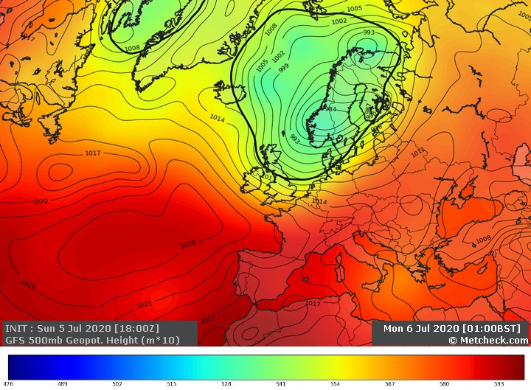
Four pairs of Swifts in boxes 2, 5, 12 and 14 were still incubating eggs at the start of this period. At least one of the pair in 2 was probably an inexperienced bird and their eggs were left for very long periods, so not included in this study. The pair in 12 started incubating at the start of the cold weather period June 3rd-12th, but left their eggs for many hours during this bad weather and finally gave up on their 2 eggs on July 2nd in this second period of cold weather. They were incubating during parts of both cold spells and after finally giving up after 27 days, one of their eggs containing a well grown embryo, ended up on the floor under the nest box. As stated in the section on the first cold weather spell, this pair left their eggs unattended for nearly 47 hours altogether, an average of over 2 hours per day over the normal incubation period. This leaves the pairs in boxes 5 and 14, whose first eggs appeared on 21/6 and 19/6 respectively. They both were on their second attempts after a change of partner in box 5 and the theft of the clutch in 14 by House Sparrows.
There are diary records and video records of the activities of the 2 Swift pairs in boxes 5 and 14, so it is possible to ascertain the total amount of time over the period from June 28th to July 12th that their eggs were not incubated.
Table 4 shows the daily absences for each pair over the period studied and the daily maximum and minimum temperatures. The periods of absence varied from 11 minutes to over 7 hours. The pair in box 5 had generally shorter absences on the majority of, but not all days compared to the pair in box 14.
Table 5 shows the total time the pairs were not incubating and the daily absence average. The pair in box 14 were absent for significantly longer periods than the pair in box 5, averaging 2 hours and 53 minutes per day over the 14 bad weather days to the 11th July and 1 hour 54 minutes per day over the total incubation period. The pair in box 5 were absent for an average of 1 hour 55 minutes per bad weather day and 1 hour 21 minutes per day over the total incubation period.
The pair in Box 5 spent a total of 28 hours 30 minutes away from the nest in the fifteen-day period, with the longest absence being 5 hours 44 minutes on the awful day that was July 9th.
The pair in Box 14 spent a total of 40 hours 18 minutes away from the nest in the fourteen-day period, before they abandoned the eggs, with a longest absence of 7 hours and 2 minutes on July 7th.
The pair in box 14 eventually abandoned their eggs on 12/7, 23 days after the first egg appeared, but the chicks in box 5 hatched from 13/7, 22 days after their first egg was laid and the pair went on to rear 2 chicks successfully.
It is possible that the eggs in 14 were not viable for some reason, but this seems unlikely as the prospective parents were an experienced pair and continued to incubate up to the 23rd day after the first egg was laid, before giving up.
Table 6 shows the daily temperatures and the average for June 28th-July 11th. Leeds had an average temperature of just 12.3 degrees over this 14-day period.
A very simple conclusion from this data confirms what is already believed, that Swifts can leave their eggs for periods of time, as their eggs can withstand a certain amount of chilling.
Perhaps the length of the periods of absence such as the 7 hours on July 7th was the reason for the failure of the clutch in box 14. Possibly, however, it was noted in the first period that some pairs were successful in rearing chicks, despite absences of up to 7 hours 18 minutes, so the length of the absences was probably not the reason for failure, rather the cumulative total of all the absences.
Both pairs in boxes 5 and 14 incubated for over the normal incubation duration of 20 days. The pair in 14 gave up on the morning of 12th July, 23 days after the first egg was laid and the eggs in 5 hatched from July 13th, 22 days after the first egg was laid.
Can it be concluded that Swifts can leave their eggs not incubated for a total time somewhere between 28 hours 30 minutes and 40 hours 18 minutes? This equates to a daily absence of between 1 hour 21 minutes (success in box 5) and 1 hour 55 minutes (failure in box 14) over an incubation period of 21 days. Supporting this theory is data from the first cold spell of 25 hours of absence from the successful pair in box 8 and the 47 hours, (from both cold periods), of the pair in box 12 that failed to hatch their eggs.
There is presumably a temperature threshold, combined with wind and rain, below which many Swifts struggle to find food. It would appear that this temperature was witnessed this year in both weather periods.
There were certainly no screaming parties of any note in either study period, so it can be assumed, the Swifts were never fully satiated during these cold times, as it is thought they only display when they have plenty of energy to do so. There were only a couple of days in the July period that could be even remotely classified as recovery days for the Leeds Swifts to catch up on feeding adequately, so it can be assumed they didn’t feed well until the cold weather ceased.
The average temperature in Leeds in this period was a paltry 12.3 degrees, which, combined with wind and rain presumably led to many Swifts struggling to find enough food for themselves and their chicks. Surely in a prolonged cold weather period, this average temperature is below that required for Swifts to successfully breed. The average temperature for the rest of July was still below the seasonal average and that may have contributed to the overall poor breeding performance as well.
There are always days in any season when Swifts can’t feed and all colony observers will have witnessed this, but to have a sustained period where Swifts struggle for days on end, is distressing to observe. Keen observers of colonies take a personal interest in the birds and many hours were spent awaiting the return of the missing incubators, especially considering the theft of 3 Swift eggs by a female House Sparrow in the first cold spell earlier in June from box 14. Indeed, whilst the observer was manning the cameras, or outside under the boxes, nervously awaiting the return of the absent Swifts in the study period, Sparrows were deterred from entering some of the boxes containing eggs on half a dozen occasions.

5. Grounded Swift Chicks
Of complementary interest, as it contributes to the evidence for poor breeding success in 2020, is that many cases of grounded Swifts came to the attention of Northern Swift carers this season. It is difficult to gauge how many more there were than in previous years, but it certainly appeared to be a bumper year for grounded, emaciated chicks of varying ages. Were swift parents selectively feeding their chicks due to food shortage? How do starving Swift chicks find themselves on the ground beneath their nests? Do they fall accidentally? Chicks can very occasionally be ejected in fights between adult, but the ones picked up for care were all undernourished, so fights seem an unlikely reason.
Up to this year at the Gledhow colony, the only place we have observed chicks dying is in the nest, due to being out competed by their siblings and/or being selectively fed by the parents. Yet one 22-day old chick, frustratingly from a non-camera nest box, was found on the ground, beheaded, so it is assumed it was alive when it ended up there.
Starving, under-developed Swift chicks were collected by Leeds Swifts from various sites, all over Yorkshire and Nottinghamshire, including one from Armthorpe, Doncaster. The chick here, like the others in this period, had somehow ended up on the ground beneath the nest site. The home-owners could see the nest site in their loft and had noted a big disparity in size between their 2 chicks. How did it end up on the ground under the loft nest space? This chick died 2 hours after collection. There is a video from another Northern colony of an outcompeted, starving Swift chick shuffling to the entrance hole and jumping out. Is this a behaviour that starving chicks have in their skill set? It would certainly explain the seemingly big increase in grounded, underweight and/or poorly developed chicks this season.
In the section on the second cold weather period, on page 7, it was noted that a starving chick at Gledhow, was removed from a camera nest box for care. This chick had hatched on 24/6 and was removed on 13/7 as it wasn’t being fed, despite its valiant efforts to get to the incoming parent before its much bigger sibling. On examination, it had the development of a 6 or 7-day old chick, despite it being 20 days since it hatched. The fact that this chick was still alive is quite amazing and despite its condition, it survived and thrived in care and developed into a handsome, normal looking Swift. However, it was unable to fly, despite appearing ready to do so. Presumably irretrievable damage must have been done when it was starving in the nest, which meant that it was never going to be able to fully develop.
According to Enric Fuste from Falciot Vencejo Swift Rehabilitation, some rehabilitated Swifts “with great body condition, do not manage to fly……...surely they crossed a red line when young and starving and some organs maybe damaged or dysfunctional.” This would explain the condition and outcome of the chick removed from its nest at Gledhow for rehabilitation. It is important to note that the centre receives many chicks every year and survival rate of those Swifts handed in to Falciot Vencejo for rehabilitation is 70-75%.
Fostering orphan chicks into carefully selected nests with step siblings of similar size is usually a good option. A chick found on the ground in Salford, Lancashire and handed in to Bury and Bolton Swifts was brought to Leeds for fostering. It was healthy and feeding well. It was fostered on June 28th into a nest of two step siblings of similar age/development. Unfortunately, this turned out to be right at the start of the long cold spell. After being accepted and all three doing well, either the fostered chick or one of its step siblings died on July 5th. After previous good experiences with fostering, this was a shock. Presumably the chick either wasn’t fed sufficiently (maybe selective feeding), or it had an unseen development problem/injury. However, it highlighted the need to take into account the predicted weather conditions when considering fostering a chick and certainly to strongly consider the advice from Enric Fuste regarding chicks where the history/background of the chick is not fully known, if at all. This advice is to rehabilitate at a centre, rather than foster.
Starving chicks, found on the ground, may have been injured in the fall from the nest space, so need a full assessment before any decisions about rehabilitation or fostering can be made.
So, although it cannot be doubted that Swifts are the ideal rehabilitators of a Swift chick, where a starving chick with unknown history is concerned, it may be best for it to be looked after by a rehabilitation centre.
Fostering a chick into a nest within the same colony, monitored by cameras, rather than introducing an outsider, is the best option as the history of the chick would be known. The age and development of a chick can then be matched to a suitable foster family and progress followed using cameras and video recordings. This was the case at Swift House in Bristol this Summer, (see page 16), where there were several successful pro-active adoptions in the second spell of cold weather.
We may have to wait for a normal season to draw conclusions, but if, as has been established, clutches of eggs were being neglected in the study period, then it follows that chicks were also neglected at many sites, as evidenced by deaths of chicks at Gledhow, Armthorpe and as we shall see, Bristol.
6. Comparisons with Bristol, Oxford and Bury St. Edmunds in the first period of cold weather, 3rd-12th June 2020
Figure 4 is the UK weather chart for Sunday June 7th 2020 and shows the extent of the low-pressure system. Northern and Eastern England was badly affected, so some colonies with chicks hatching at the start of this period may well have suffered some losses.
Figure 4. UK pressure and temperature chart Sunday 7th June 2020
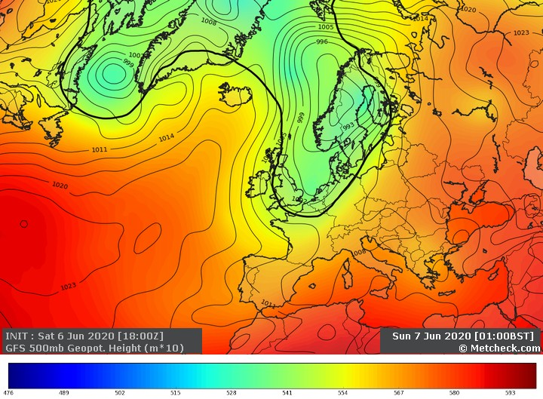
Table 7 lists the maximum and minimum and average temperatures at Leeds, Bristol, Oxford and Bury St. Edmunds in the early June cold spell, along with the average temperature for June from 2015-2019. These locations all have notable Swift colonies, but plenty of others could have been looked at. Did the cold weather in this period affect these colonies?
From the earlier section on the first cold spell, it is clear that Swifts at the Leeds colony struggled in this period. At Gledhow, those Swifts with eggs/chicks left them unattended/not brooded for long periods. However, the first chicks only hatched on June 8th, towards the end of the cold spell, so only had to endure a few days of hardship. Overall, possibly due to fortuitous timing, apart from the failure of the pair in box 12 and the loss of a complete clutch to a Sparrow, no obviously widespread direct harm was done to eggs or chicks at the Gledhow colony, in this period.
It is worth stating that average temperatures at the four locations in this period, were all well below the averages in the 28th June-11th July study period.
There is a famous colony of Swifts in Oxford at the tower of the University Natural History Museum (OUNHM). The book “Swifts in a Tower”, by David Lack, is essential reading for Swift enthusiasts.
From the final OUNHM Swift diary entry for 2020, it can be concluded that this colony suffered in the poor June weather. The entry from August 17th reads as follows: “It was a strange breeding season; the early weeks were full of hope and hot weather, then June happened - cold and wet weather discouraged many. Two adults were found dead, eggs were being ejected from nests and chicks began to die. A situation probably caused by a combination of cold wet weather and lack of insect food.” George Candelin, the Keeper of the Oxford Swifts confirmed this summary in an e mail “2020 was unusual in that encouraged by the warm weather, laying began early and consequently so did hatching. Unfortunately, the wet and cold weather arrived when the chicks were most vulnerable; Swifts are not synchronous in their breeding so some eggs were deserted, some chicks died and many adults were not in great condition.” Also, he summarised the 2020 breeding season as follows: “Our normal Annual average is 55 boxes occupied producing 110 eggs of which 75% hatch and of these 96% young fledge; compare this with 2020 where 53 boxes produced 109 eggs of which 74% hatched but only 85% of these fledged, the highest chick mortality we have recorded since 1948.” The final count was 69 chicks ringed from 109 eggs. (80 ringed in 2019).
From the study of the diary and video records, it is clear that the temperature of 12.3 in Leeds in the second study period was low enough to cause serious shortages of insects at that colony. Here the report from Oxford cited the cold weather in the first period, with an average of 13.2 degrees, as the main reason for the poor breeding season there. It becomes clear that any pairs at Oxford with chicks hatching at the start of this cold spell may well have struggled to brood and feed for 9 cold days.
From that, it follows that the other colonies may well have struggled in this early June period as all the locations had extremely low average temperatures. These were 9.7 degrees for Leeds, 11.8 degrees for Bury St. Edmunds, 12.4 degrees for Bristol and 13.2 degrees for Oxford.
In fact, the cold spell had ended by 11/06 for both Bury St. Edmunds and Oxford and the averages from 03/06-11/06 were lower at 11.3 degrees for Bury St. Edmunds and 12.8 degrees for Oxford.
Swift House in Bristol, is the location of another well-known Swift colony. Mark Glanville writes a Blog on the happenings there. In this first weather period, the Bristol Swifts managed to get through the first cold spell seemingly unscathed, but Mark made an interesting observation in a diary entry from June 7th on an awful day, as follows: “Something I’ve never seen before is just after the third egg hatched both adults in nb3 north departed. They left their 3 chicks uncovered for nearly two hours during the afternoon. It was quite cold and all 3 chicks struggled to keep warm. When one of the adults finally returned the chicks had gone into a torpor. The adult had to warm up the chicks for a good 10 minutes before it was able to feed them. Normally when eggs hatch one adult will sit on the chicks whilst the other collects food. They don’t normally leave their chicks uncovered until they are at least a week old. I’ve never seen such young chicks left unattended by their parents before.”A similar report to happenings in Leeds, but seemingly no direct harm done and certainly nothing like the problems caused by the second period of bad weather.
The temperatures for Bury St. Edmunds are included as there’s a growing colony of Swifts at the Church of St. John. A report from Simon Evans on Twitter indicates a good breeding season, with 48 fledged chicks:” Latest check up on the swifts of St John’s in Bury St Edmunds with @BlaenavonNatureMost fledged but still a few developing. 48 chicks this year, it’s best so far.” This is up 7 on the 2019 figure: “In 2019, 41 chicks from 19 pairs were ringed from the swift boxes at St John’s.” Interestingly, Bury St. Edmunds endured the same cold 9 days in June as Oxford, with an even colder average temperature of just 11.3 degrees. It would be interesting to see if any losses occurred at St. John’s in that period. If so, the numbers of fledged chicks may have been even more impressive. It is a growing colony, so if indeed there were losses caused by the first cold spell, they could be masked by the overall growth figure. Without close monitoring, it is only speculation about the impact of the cold weather on breeding Swifts in the first weather period, but in an e mail response from Simon Evans, about that first period, he wrote that: “Our long-standing site at Worlington was definitely down in terms of productivity so may well have been affected.”
Maybe the fact that this was a shorter period of cold weather, possibly lessened its impact, but the report from Oxford implicated this cold spell as the reason for their disappointing breeding season.
The timing of this cold spell may have been especially critical for colonies where chicks were hatching at the beginning of a presumed insect shortage. At Gledhow, the first chicks only hatched on 08/06 and 09/06, towards the end of this cold spell. If they had hatched a few days earlier, it could have led to a much worse breeding season! Adults having to leave tiny chicks for long periods can lead to reduced productivity as parents struggle to find food and keep chicks warm. With the breeding cycle in Southern colonies tending to be a few days ahead of colonies further North, they may well have been affected differently. This is mainly conjecture, based on the Oxford Tower Swifts, but might account for any unexplained, lower than usual productivity numbers for colonies without the benefit of cameras and video recording.
Thus, lots of colonies with young chicks may well have suffered in this first cold spell and it could explain any lower than average productivity in colonies not affected by the second cold spell. There were other cold days in June, but not for prolonged periods of more than 2 days. Adult Swifts seem to be able to cope with short periods of insect shortage, as can chicks and eggs. However, it seems that a cold spell of a week or more can have devastating consequences for breeding success, as the adults then struggle to find sufficient food for themselves, leaving chicks un-brooded and hungry and eggs not incubated.

7. Comparisons with Bristol, Oxford and Bury St. Edmunds in the Second Period of Cold Weather, June 28th-July 11th 2020
Table 8 shows the maximum, minimum and average temperatures at Leeds and three other locations in the second period studied. Did the cold weather in this period affect these colonies?
It has already been concluded that this long spell of cold weather was responsible for much of the poor breeding performance of the Gledhow Swifts.
Reports from Mark Glanville’s Bristol colony blog indicate a poor Swift season there with just 21 chicks fledged from 32 eggs. This would have been even worse had it not been for some selective adoptions by Mark to improve the chances of survival of various chicks. The average temperature there in the second period was 14.3 degrees, 2 degrees warmer than Leeds, but the Swifts still encountered difficult conditions for successful breeding. Mark’s final blog of 2020 was as follows: “Everything was going really well until the end of June. That’s when the weather changed for the worse. Just as the eggs were beginning to hatch it turned unseasonably wet and windy. Day after day of wind and rain turned into week after week. All this poor weather eventually started to have a negative impact on the colony. Eggs were ejected and chicks died. Out of the 32 eggs that were laid, 6 were abandoned. Sadly 2 chicks died almost immediately after hatching because of the lack of food. The prolonged spell of bad weather also resulted in some adults abandoning their chicks. Fortunately, I had enough spare capacity in my other boxes to rehome them. In the end I fostered 6 chicks. All I’m pleased to say fledged. The nadir was on Sunday 11th July when 3 chicks died within a few hours of one another. Out of 26 hatchlings I had now lost 5. It was turning out to be a disastrous year for chicks. Their mortality rate was double of previous years at almost 20%. The weather finally improved around the middle of July.”
The similarities with the conditions in Leeds are there. When all the negative insect supply factors of wind, rain and low average temperature align, insect numbers are suppressed and desperate feeding conditions are created. Just as in Leeds, this period of cold weather was responsible for the poor breeding performance at Swift House in Bristol. It would seem that fourteen days of struggle to find sufficient food supplies had a huge impact on breeding success in the parts of England where average temperatures were below 15 degrees.
As stated in the section on comparisons with Bristol, Oxford and Bury St. Edmunds in the first period of cold weather, 3rd-12th June 2020, reports from the famous Oxford Swifts in the Tower indicated a disappointing season there too. The difference being that the main problems for their Swifts occurred in early June, although in an e mail about the 2020 season, George Candelin, Keeper of the Oxford Swifts, observed that “The second cold period also caught the birds at a time when the second wave of chicks were vulnerable so 2020 was in fact a double whammy for the breeding pairs and their offspring.”
As the average temperature in Oxford in the mainly July study period was 15.1 degrees, a full 2.8 degrees warmer than Leeds, it is likely that this period on its own, would not have been a problem for the Tower Swifts. However, it followed the disastrous earlier cold spell where the average temperature for the period 3rd-11th June was just 12.8 degrees in Oxford and thus it made for the double whammy referred to by George Candelin and caused further problems for the Oxford Swifts.
The average temperature at Bury St. Edmunds in the second study period was 15.7 degrees, a full 3.4 degrees warmer than Leeds, then 17.2 for the rest of the month. There were no adverse reports from Simon Evans at the colony at St. John’s Church, about this weather period. The average temperature here was 0.6 degrees higher than that at Oxford in this 28th June-11th July period and it seems likely that the weather conditions here at this time didn’t create desperately low levels of insect numbers, as occurred in Leeds and Bristol. The average temperatures in Bury St. Edmunds presumably meant that Swifts could still feed sufficiently well to be able to feed their growing families.

Figure 5. UK pressure and temperature chart Friday July 10th 2020
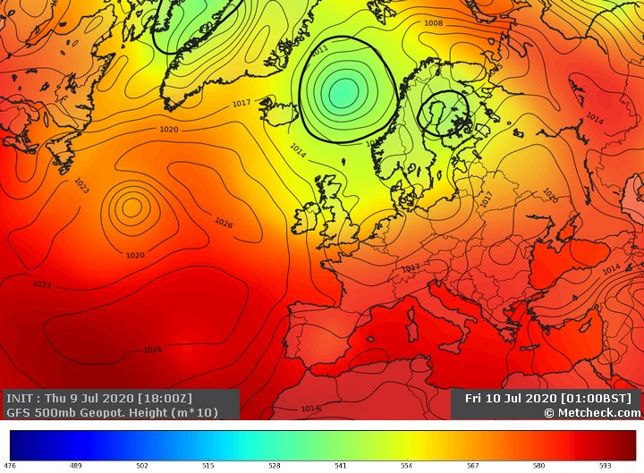
Finally, as can be seen from Figure 5 the low pressure that had dominated the weather for two weeks, was moving away. It was apparent from the resumption of screaming parties and “bangers” on the morning of Saturday July 11th, that insect supplies had started to re-appear and increase.
There does appear to be a temperature threshold, above which, Swifts can fare sufficiently well and below which they struggle to find food. Thus, even if temperatures are below average, but not below the threshold, Swifts seem to be able to cope and still find insects.
Backing up this theory regarding a temperature threshold, it can be seen from Table 9 that the average temperatures in all four locations in the second cold spell were around three degrees lower than the whole of July average for the last five years. This was under 15 degrees for both the Leeds and Bristol colonies, where the Swifts struggled to find enough food, 15.1 degrees for Oxford where Swifts may still have struggled to find enough insects and 15.7 degrees for Bury St. Edmunds where perhaps insects were still in reasonable supply. This does seem to suggest that a figure close to 15 degrees is the critical, threshold average daily temperature in the life of a Swift.
8. Other factors influencing breeding success.
Firstly, if there are recovery days in a prolonged poor weather period, they might mitigate against the hardship caused by the overall length of said period. It is a fact that Swifts make the most of good conditions for feeding and fully maximise all opportunities for feeding by staying out as late as possible. It is assumed that although they can sense a deep low-pressure system, they can’t predict the next day’s weather, so they make the most of good conditions. They often return with a bolus of insects for their chicks in semi-darkness, just when one is thinking they may have left it too late to find the entrance.
Daily maximum temperatures may have a big influence on insect supplies, despite any accompanying low daily minimum temperatures. Both Oxford and Bury St. Edmunds fared well in daily maximum temperatures in the study period and these sites had slightly more recovery days in this period of prolonged poor weather. This probably also contributed to these Swifts seemingly faring well in this period, whilst others struggled.
Timing of hatching can be vital. If chicks hatch at the start of a long cold weather spell, then the adults firstly have to find enough food to keep themselves alive, then find food for the chicks, whilst trying to brood them sufficiently to prevent death. Thus, any prolonged period of cold weather can have disastrous consequences for both adult and chick mortality. Up and down the country, many chicks will have been hatching at the start of both weather periods, so any unexplained poor breeding figures might be down to timing. Adults with chicks hatching at the start of the fourteen-day cold spell would have struggled to find enough food for themselves as well as having to feed and brood chicks.
Also, as mentioned before, colonies near enough to large water bodies may be able to survive prolonged cold weather, due to more reliable supplies of insects associated with the water bodies.
Experience of the breeding pairs also plays a part. Some of the pairs at the Gledhow colony managed to cope with the cold weather and two experienced pairs each fledged 3 chicks, whilst others certainly struggled.

Swift Chick at the Gledhow colony 2014.
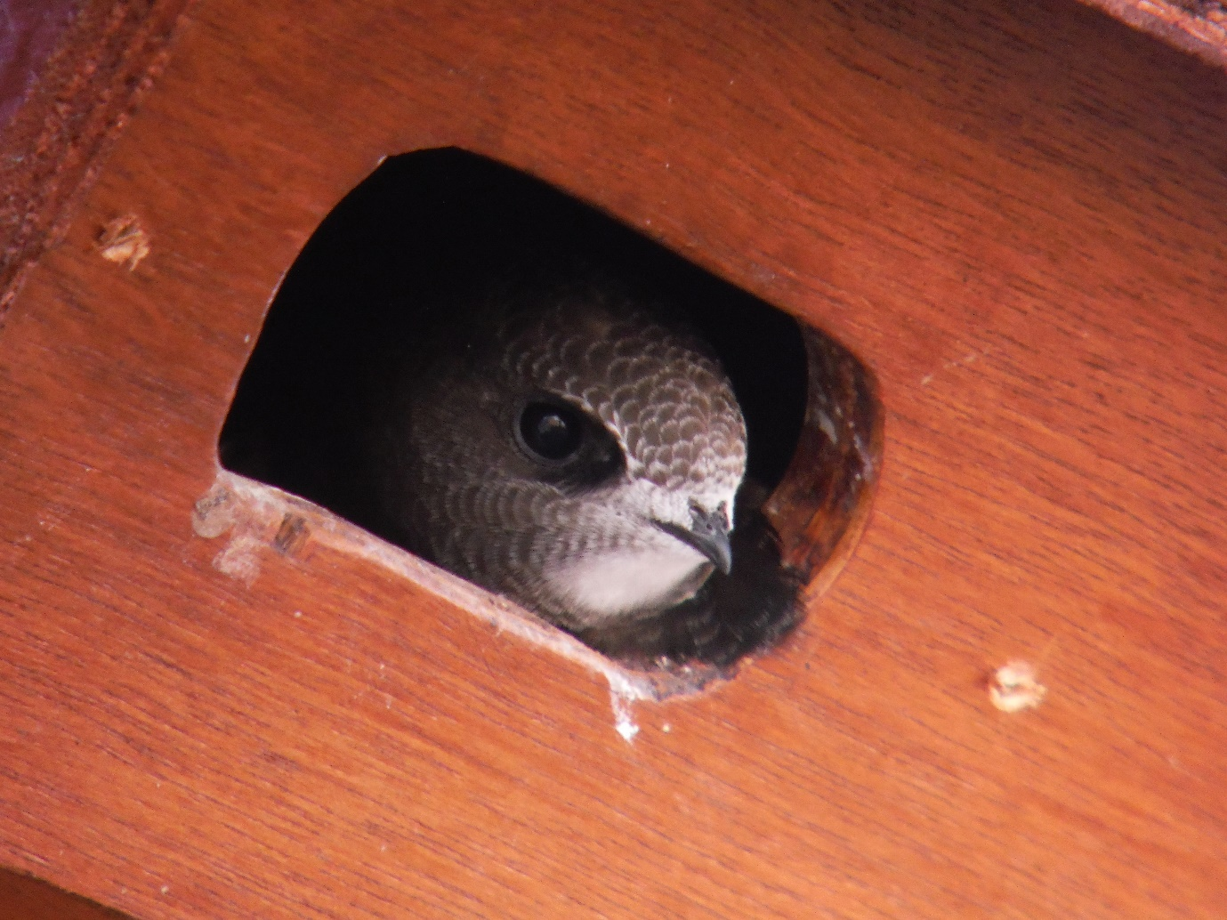

9. Conclusions
1. From Table 9, it can be seen that the average temperature in July 2020 in Leeds was 14 degrees. This is only a degree below the average for the last 5 years. However, the average temperature from June 28th to July 11th was only 12.3 degrees. This was probably the main cause of the exceptional behaviour witnessed this year, being the prolonged neglection of eggs and chicks for long periods. This, along with the extremely challenging weather of early June, albeit for a shorter length of time, must have been the cause of the poor overall breeding performance in 2020.
2. There must be a critical temperature and associated conditions, below which, Swifts suffer food hardship, as insect supply dwindles in direct correlation to falling temperature. From this simple study of conditions at Leeds and Bristol, it would seem that an average temperature of 14.3 degrees Celsius or less, combined with the strong wind and heavy rain that often accompanies low temperatures, causes a shortage of insects. If this weather lasts for more than a few days, it leads to Swift parents selectively feeding their chicks, leading to some going hungry, their development being impaired and sometimes their deaths. As soon as one or two chick(s) start to dominate the incoming feeds, it is very difficult for a smaller chick to compete. The struggle of the adults to find enough food can lead to eggs not being brooded for long periods, so that embryos too, don’t develop enough for successful hatching.
The initial intention of this research was simply to try to explain the poor breeding performance at the Gledhow Swift colony. However, once the weather and temperatures were studied along with the large weather movement of Swifts in late June, it was a natural progression to consider breeding success elsewhere. The Swifts at Oxford struggled in average temperatures of 12.8 degrees in the first cold spell and the Bristol colony likewise in the second cold period where average temperatures were 14.3 degrees. It would seem therefore, that average temperatures of below 15 degrees for more than a couple of days can be a cause of poor breeding success. Conclusions from this limited sample cannot be very broad, but it can be concluded that some Swift colonies elsewhere will have had difficult seasons as well.
3. For Gledhow specifically, the statistics from the first cold weather period, showed that 6 pairs of Swifts left their eggs unattended over a 7-day period for up to 236 minutes per day, but 4 of these pairs still managed to hatch chicks that fledged successfully. This would imply that the amount of average absence per day over the total incubation period is the determining figure with regard to whether the eggs hatch or not. Of these 4 pairs, box 8 had the highest total of absence of 24 hours 56 minutes, equating to 71 minutes a day over the total incubation period. The failed pair in box 12 were absent for a total of 46 hours 59 minutes, equating to 134 minutes a day over the total a normal incubation period. Their eggs failed to hatch, despite incubating for 27 days. This data indicates that the maximum amount of time eggs can be left is between 71 and 134 minutes per day over the total incubation period.
The data from the second period enables us to get closer to finding the maximum amount of time that eggs can be left unattended. These figures lead to a narrowing of the range established in the first period, of between 71 and 134 minutes of absence per day, as follows.
4. In the second period, the pair of Swifts in box 5 at Gledhow, left their eggs unattended for a total of 28 hours and 30 minutes, an average of 114 minutes a day over a 15-day cold period towards the end of incubation. This was an average of 81 minutes a day over the whole 20-22 days of incubation. The eggs hatched successfully and 2 chicks fledged in late August.
The other study pair, in box 14 at Gledhow, left their eggs unattended for a total of 40 hours and 18 minutes, an average of 193 minutes per day over 14 days of cold weather. This is an average of 115 minutes per day over a full incubation period of 21 days. This pair failed to hatch their eggs.
There may be more variables affecting successful eggs, such as efficiency of incubation and the amount of experience of the adults, but a simple conclusion from the data is that a figure somewhere between 81 and 115 minutes of absence per day, over the incubation period, is the maximum amount of time that eggs can be left unattended.
In 2020, the normal incubation of around 20-21 days was extended by at least a couple of days for three of the pairs studied, so it might be better just considering the total absence from incubation, rather than using a “normal” incubation period for calculating the above. The conclusion then is that the maximum amount of time that Swift eggs can be left unincubated and still be successful is somewhere between 28 hours 30 minutes and 40 hours 18 minutes.
5. Maybe it has to be accepted, therefore, that there is a fine line between success and failure in some northerly and other parts of the range of Swifts, unless there are mitigating factors, such as extremely large water bodies, with a constant supply of insects. It certainly seems that Swifts were on the wrong side of the “fine line” on too many days in the 2020 breeding season.

The 2020 Swift Summer produced exceptional conditions and led to behaviour not witnessed before at the Gledhow colony. On the evidence of many hours of Swift watching, video evidence and diary records, it seems reasonable to conclude that average temperatures of 9.6 degrees and 12.3 degrees, combined with wind and rain, for the two prolonged periods, resulted in desperately low insect numbers. This, in turn, lead to failed clutches and chick mortality at this colony. This produced a return of 56% for egg success against the average of 80% from 2013 to 2019. Watching Swifts struggle to breed successfully was an experience that hopefully won’t be repeated anytime soon.

Martin P. Calvert, Leeds Swifts, November 2020.

Appendix to the study of the consequences of two cold weather periods in the 2020 Swift breeding season at Gledhow, Leeds, in particular and the swift breeding season in general.
TABLES 1-3 RELATING TO FIRST WEATHER PERIOD 03/06-12/06 2020
Table 1. lengths of time in minutes swift eggs unattended in nest boxes at the swift colony at Gledhow, Leeds and max/min Leeds temperatures 03/06-12/06 2020
date | box 3  mins absent | box 8 mins absent | box 11 mins absent | box 12 mins absent | box 14 mins absent | Box 15 mins absent | Temp Celsius max/min
last egg laid | 25/05 | 03/06 | 05/06 | 03/06 | 05/06 | 03/06
incubation started | 25/05 | 03/06 | 05/06 | 03/06 | 05/06 | 03/06
03/06 | None | None | n/a | None | n/a | None | 14/8
04/06 | * | * | ** | * | ** | * | 12/6
05/06 | * | * | * | * | * | * | 12/5
06/06 | 207 | 120  est from diary | nothing recorded | 216 | 416 and eggs stolen | nothing recorded | 14/6
07/06 | 290 | 438 | 505 | 280 | - | 422 | 10/7
08/06 | 130 | 455 | 200 | 573 | - | 225 | 13/6
09/06 | 80 | 68 | 55 | 195 | - | nothing recorded | 14/6
10/06 | 18 | 192 | 61 | 312 | - | 108 | 12/8
11/06 | 122 | 138 | 91 | 119 | - | nothing recorded | 12/8
12/06 | 90 | 85  est from diary | * | 85  est from diary | - | 326 | 12/9
*Denotes diary record of “sitting TIGHT” **denotes clutch not complete

Table 2 total absences in minutes 04/06-12/06 2020 and absence per day over total incubation period
 | Box 3 | Box 8 | Box 11 | Box 12 | Box 14 | Box 15
Total absences in hrs/mins | 11 hours 16 minutes | 24 hours 56 minutes | 15 hours 12 minutes | 29 hours 40 minutes  6/6-12/6  add 17 hours 19 minutes 30/6-2/7 | 6 hours 56 minutes | 18 hours 1  minute
Absence per day over 7 days in mins | 97 | 213 | 130 | 254 | n/a | 154
Absence per day in mins over 21-day incubation period | 32 | 71 | 43 | 134 | n/a | 51
Table 3. Max/ min Temperatures and average temperatures Leeds 3/06-12/06 2020
Date | Max/min temperature | average temperature
03/06 | 14/8 | 11
04/06 | 12/6 | 9
05/06 | 12/5 | 8.5
06/06 | 14/6 | 10
07/06 | 10/7 | 8.5
08/06 | 13/6 | 9.5
09/06 | 14/6 | 10
10/06 | 12/8 | 10
11/06 | 12/8 | 10
12/06 | 12/9 | 10.5
average max/min and average temp 03/06-12/06 2020 | 12.4/6.9 | 9.7
Source: https://www.accuweather.com/en/gb/leeds/ls1-6/june-weather/712327?year=2020

TABLES 4-6 RELATING TO SECOND WEATHER PERIOD 28/06-11/07 2020
Table 4. lengths of time in minutes swift eggs unattended in boxes 5 and 14 at the swift colony at Gledhow, Leeds and max/min Leeds temperatures in the study period, 28/06/2020-12/07/2020
28/06 | 30* | 30* | 15/10
29/06 | 30* | 30* | 12/9
30/06 | 211 | 61 | 15/11
01/07 | 200* | 200* | 18/12
02/07 | 110* | 264 | 12/9
03/07 | 90 | 114 | 16/11
04/07 | 21 | 206 | 18/14
05/07 | 95 | 270 | 16/10
06/07 | 161 | 208 | 16/9
07/07 | 96 | 422 | 12/10
08/07 | 12 | 11 | 13/9
09/07 | 344 | 301 | 11/9
10/07 | 179 | 175 | 16/8
11/07 | 94 | 126 | 16/8
12/07 | 37 | 609** | 19/8
13/07 | Chick hatched | Eggs abandoned
Source: https://www.accuweather.com/en/gb/leeds/ls1-6/june-weather/712327?year=2020
* Denotes estimate based on diary entry. Video recording evidence not available for these days.
** Denotes assumption that eggs were abandoned on 12/07
Table 5. summary of absences in boxes 5 and 14 at the swift colony at Gledhow, Leeds from 28/06-11/07 2020.
 | Box 5 | Box 14
Total time eggs unattended minutes | 1710 mins over 15 days | 2418 mins over 14 days or 3027 mins over 15 days ***
Total time eggs unattended hours/mins | 28 hours 30 mins over 15 days | 40 hours 18 mins over 14 days*** (or 50 hours 27 mins over 15 days)
Average per day hours/mins  Over 15 days (box 5) and 14 days (box 14) | 1 hours 54 mins | 2 hours 53 mins***
Average per day over total incubation period approx. 21 days | 1 hour 21 min | 1 hour 55 mins
Maximum length of time eggs unattended | 5 hours 44 mins (9th July) | 7 hours 2 mins (7th July)

*** By 12/07 the pair in 14 had given up on the eggs, so the absence of 609 minutes on 12/07 is not included when calculating the average absence per day figure for this pair.

Table 6. Max/ min Temperatures and average temperatures Leeds 28/06-11/07 2020
DATE | MAX/MIN TEMPERATURE | AVERAGE TEMPERATURE
28/06 | 15/10 | 12.5
29/06 | 12/9 | 10.5
30/06 | 15/11 | 13
01/07 | 18/12 | 15
02/07 | 12/9 | 10.5
03/07 | 16/11 | 13.5
04/07 | 18/14 | 16
05/07 | 16/10 | 13
06/07 | 16/9 | 12.5
07/07 | 12/10 | 11
08/07 | 13/9 | 11
09/07 | 11/9 | 10
10/07 | 16/8 | 12.5
11/07 | 16/8 | 12
AVERAGE MAX/MIN and AVERAGE TEMPERATURE | 14.7/9.9 | 12.3
Source: https://www.accuweather.com/en/gb/leeds/ls1-6/june-weather/712327?year=2020

TABLES 7-9 RELATING to temperature comparisons with Bristol, Oxford and Bury St. Edmunds

Table 7. maximum/minimum Celsius temperature and average temperature 1st-2nd, 3rd-11th,
3rd-12th and 13th-30th June 2020 at LEEDS, BRISTOL, OXFORD AND BURY ST. EDMUNDS.
Dates in June 2020 | Max/min temp Leeds | Max/min temp Bristol | Max/min temp Oxford | Max/min temp Bury St. Edmunds
01/06 | 22/9 | 24/11 | 26/9 | 23/8
02/06 | 23/8 | 24/12 | 24/8 | 22/8
Av temp 01/06-02/06 2020 | 15.5 | 17.7 | 16.7 | 15.2
03/06 | 14/8 | 18/9 | 17/10 | 17/10
04/06 | 12/6 | 14/8 | 15/10 | 15/9
05/06 | 12/5 | 16/7 | 18/8 | 12/7
06/06 | 14/6 | 12/6 | 14/6 | 14/6
07/06 | 10/7 | 18/7 | 18/4 | 15/6
08/06 | 13/6 | 18/9 | 17/7 | 15/7
09/06 | 14/6 | 18/8 | 20/10 | 17/3
10/06 | 12/8 | 16/10 | 15/11 | 14/9
11/06 | 12/8 | 16/10 | 19/11 | 18/9
Av temp 03/06-11/06 2020 | 9.6 | 12.2 | 12.8 | 11.3
12/06 | 12/9 | 18/11 | 22/12 | 21/12
Av temp 03/06-12/06 2020 | 9.7 | 12.4 | 13.2 | 11.8
13/06 | 21/11 | 20/10 | 24/11 | 23/13
14/06 | 20/11 | 20/12 | 23/9 | 23/11
15/06 | 21/12 | 21/11 | 24/8 | 23/12
16/06 | 20/13 | 20/13 | 23/11 | 23/12
17/06 | 19/11 | 21/12 | 23/9 | 20/12
18/06 | 13/11 | 15/13 | 17/13 | 20/13
19/06 | 15/11 | 15/12 | 19/12 | 19/12
20/10 | 20/10 | 18/12 | 22/11 | 20/9
21/06 | 18/11 | 17/11 | 21/10 | 21/12
22/06 | 20/9 | 20/10 | 23/7 | 22/10
23/06 | 23/14 | 25/12 | 27/11 | 25/12
24/06 | 26/17 | 28/13 | 31/14 | 28/15
25/06 | 26/14 | 30/16 | 31/19 | 28/14
26/06 | 26/15 | 21/14 | 29/14 | 28/15
27/06 | 19/11 | 17/11 | 20/13 | 21/14
28/06 | 15/10 | 16/11 | 19/11 | 20/12
29/06 | 12/9 | 14/12 | 19/12 | 20/11
30/06 | 15/11 | 17/12 | 19/12 | 20/12
Av temp 11-30 June 2020 | 15.3 | 15.8 | 17.3 | 17.3
Av June 2020 temperature | 13.6 | 14.9 | 15.9 | 15.4
Av June temperature 2015-2019 | 13.4 | 15.2 | 15.6 | 15.6
Source: https://www.accuweather.com/en/gb/oxford/ox1-3/june-weather/330217?year=2020
Table 8. Celsius temperatures at four locations 28/06-11/07 2020, 12/07-31/07 2020 and 01/07-31/07 2020 for LEEDS, BRISTOL, OXFORD AND BURY ST. EDMUNDS
Date | Temp max/min  Leeds | Temp max/min  Bristol | Temp max/min  Oxford | Temp max/min Bury St Edmunds
28/06 | 15/10 | 16/11 | 19/11 | 20/12
29/06 | 12/9 | 14/12 | 19/12 | 20/11
30/06 | 15/11 | 17/12 | 19/12 | 20/12
01/07 | 18/12 | 16/12 | 21/11 | 19/14
02/07 | 12/9 | 17/12 | 21/9 | 19/12
03/07 | 16/11 | 17/12 | 21/9 | 21/11
04/07 | 18/14 | 16/15 | 20/14 | 21/14
05/07 | 16/10 | 16/12 | 20/13 | 23/13
06/07 | 16/9 | 17/11 | 20/10 | 19/11
07/07 | 12/10 | 16/12 | 20/7 | 18/9
08/07 | 13/9 | 17/14 | 19/13 | 17/12
09/07 | 11/9 | 18/13 | 20/13 | 21/13
10/07 | 16/8 | 17/10 | 19/7 | 17/11
11/07 | 16/8 | 19/9 | 21/4 | 18/8
Av temp 28/06-11/07 2020 | 12.3 | 14.3 | 15.1 | 15.7
12/07 | 19/8 | 20/8 | 24/5 | 21/8
13/07 | 17/12 | 18/13 | 23/9 | 22/11
14/07 | 15/10 | 17/12 | 20/14 | 20/13
15/07 | 14/11 | 16/12 | 19/12 | 19/10
16/07 | 17/12 | 20/14 | 25/15 | 20/14
17/07 | 21/14 | 19/14 | 26/13 | 25/16
18/07 | 17/12 | 18/14 | 24/13 | 23/14
19/07 | 17/9 | 20/11 | 22/11 | 20/12
20/07 | 16/7 | 19/10 | 20/5 | 20/9
21/07 | 16/9 | 20/9 | 22/5 | 19/9
22/07 | 17/12 | 21/13 | 25/9 | 22/12
23/07 | 17/12 | 17/12 | 25/10 | 23/13
24/07 | 20/11 | 20/15 | 25/16 | 24/15
25/07 | 19/13 | 18/14 | 23/12 | 24/15
26/07 | 19/12 | 18/14 | 22/10 | 22/12
27/07 | 19/11 | 19/13 | 21/12 | 20/15
28/07 | 14/10 | 17/11 | 20/8 | 20/12
29/07 | 16/10 | 19/11 | 23/6 | 21/9
30/07 | 22/11 | 25/12 | 28/10 | 26/14
31/07 | 31/14 | 29/15 | 37/16 | 32/16
Av temp 12/07-31/07 2020 | 15.3 | 15.9 | 17.1 | 17.2
Av temp 1-31 July 2020 | 14.3 | 15.4 | 16.4 | 16.7
Source: https://www.accuweather.com/en/gb/bristol/bs1-6/july-weather/327328?year=2020

Table 9. average July Celsius temperatures and maximum/minimum temperatures 2016-2020 and rolling average temperature. Table 10.
 | Av temp July 2020 | Max/min temp July 2020 | Av temp July 2019 | Max/min temp July 2019 | Av temp July 2018 | Max/min temp July 2018 | Av temp July 2017 | Max/min temp July 2017 | Av temp July 2016 | Max/min temp July 2016 | Av July temp 2015-2019
Leeds | 14.3 | 31/7 | 17 | 32/8 | 18 | 29/9 | 15 | 24/9 | 14 | 30/7 | 16
Bristol | 15.4 | 29/8 | 17 | 30/10 | 19 | 29/12 | 16 | 26/10 | 16 | 30/9 | 17
Oxford | 16.4 | 37/5 | 19 | 37/5 | 20 | 33/10 | 17 | 31/8 | 17 | 33/6 | 18
Bury St. Edmunds | 16.7 | 32/8 | 19 | 34/9 | 20 | 34/11 | 17 | 26/10 | 17 | 28/9 | 18
Sources: https://www.accuweather.com/en/gb/bury-st-edmunds/ip33-1/july-weather/325689?year=2020

TABLE 10. BREEDING SUCCESS AT GLEDHOW 2015-2020

Year | Eggs Laid | Swifts Fledged | Percentage Success
2015 | 10 | 8 | 80
2016 | 13 | 12 | 92
2017 | 21 | 17 | 81
2018 | 23 | 20 | 87
2019 | 29 | 25 | 86
2020 | 34 | 19 | 56

.

https://www.metoffice.gov.uk/binaries/content/assets/metofficegovuk/pdf/weather/learn-about/uk-past-events/summaries/uk_monthly_climate_summary_202007vn2.pdf
https://www.metcheck.com/WEATHER/gfs_reanalysis_1871_now.asp 6th June 2020
https://www.metcheck.com/WEATHER/gfs_reanalysis_1871_now.asp date 28th June 2020
https://www.trektellen.nl/species/records/0/0/249/6/0?g=&l=&k= numbers 3-11 in the list
https://www.birdguides.com/articles/general-birding/a-british-record-day-for-common-swift-passage/ by Ben Ward
https://www.trektellen.nl/species/records/0/0/249/6/0?g=&l=&k= no.1 in list or https://www.trektellen.nl/count/view/20/20200628
https://www.trektellen.nl/species/records/0/0/249/6/0?g=&l=&k= no.2 in list or https://www.trektellen.nl/count/view/20/20200629
GENTON, B. & JACQUAT, M.S. (2014) : Martinet noir : entre ciel et pierre. Cahiers du MHNC n° 15, Editions de la Girafe, La Chaux-de-Fonds.
https://www.accuweather.com/en/gb/birmingham/b5-5/july-weather/326966?year=2020
E mail from Alastair from Kingsteignton Swifts July 3rd 2020
Dick Newell from Action for Swifts http://actionforswifts.com/2013/02/how-many-swifts-are-there-in-gb-and-uk.html
E mail from Dick Newell, Action for Swifts June 29th 2020
https://www.trektellen.nl/species/records/0/0/249/6/2020?g=&l=&k= no.20 in list
https://www.trektellen.nl/species/records/0/0/249/6/2020?g=&l=&k= no.21 in list
https://www.metoffice.gov.uk/binaries/content/assets/metofficegovuk/pdf/weather/learn-about/uk-past-events/summaries/uk_monthly_climate_summary_202007vn2.pdf
E mail from Enric Fuste Henares 28th August 2020. Website www.falciotnegre.com
https://www.bristolswifts.co.uk/bristol-swift-2020-blog/ Fri 7th August 2020
https://www.metcheck.com/WEATHER/gfs_reanalysis_1871_now.asp June 7th 2020
https://www.oumnh.ox.ac.uk/swifts-diary 17 Aug 2020
E mail from George Candelin, Keeper of the Swifts, Museum of Natural History, University of Oxford 17th November 2020.
https://www.bristolswifts.co.uk/bristol-swift-2020-blog/ Sunday June 7th 2020
Simon Evans on twitter. @Spe24Simon August 4th 2020
https://stjohnsburystedmunds.co.uk/index.php/eco-church/swifts/
E mail from Simon Evans 9th October 2020
https://www.bristolswifts.co.uk/bristol-swift-2020-blog/ Fri 7th August 2020
E mail from George Candelin, Keeper of the Swifts, Museum of Natural History, University of Oxford 17th November 2020.
https://www.metcheck.com/WEATHER/gfs_reanalysis_1871_now.asp 10th July 2020
Swift chick at Gledhow, Leeds in 2014. Photograph by Linda Jenkinson of Leeds Swifts and www.startbirding.co.uk

