Over het V-teken, V-sign
Korte tijd (1-2 seconden) vliegen met de vleugels stil in V-vorm omhoog gehouden.
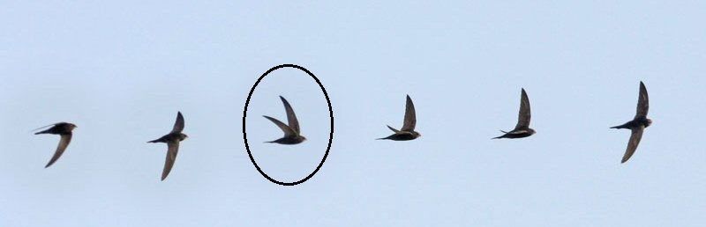
Antwoorden van ervaren gierzwaluwkenners op het Engelse gierzwaluwforum juni 2022.
Zie: https://groups.google.com/g/swallows-martins-swifts-worldwide .
Jonatham Pomroy: (Engeland)
I've just watched an incubating bird leave the box. It was immediately persued by another swift. The incubating bird V displayed to the bird behind. It is clearly not a courtship display. I think it means "back off." Or could it be a sign to another member of the colony? I've seen paired birds with mates in the nest site V display to others many times. I've just seen another classic "back off" V when an adult with young was chased as it left the box. There are different extremes of V’s, so perhaps even different messages? But mainly it seems to mean ‘stop chasing me’.
Louis-Philippe Arnhem (B)
I think that it can signify "back-off", as I observed the same behaviour when one of my Swifts from the camera box (the male) showed also a V-sign when leaving the box as he was followed by another Swift. But maybe it means other things in different situations.

Ulrich Tigges (D)
For me "back off" is fine, I saw it from the first to the last day of their presence. Our Italian friends think the same from the similar behaviour of pallid swifts.

Mark Smyth (Noord-Ierland)
Yesterday while swift watching I have come to the conclusion V means either “stay away” or maybe “I'm not in the mood”. It could also be a threat. It happens when one swift swift is doing its own thing and another approaches at speed.

Henk Schreuders, NL, Hattem
Ik denk “volg mij”. Meestal na die V-houding zoeken ze toenadering en vliegen ze in een duo kort achter elkaar verder.

Evert Pellenkoft, NL-Amsterdam
l think you are right, Ulrich. There is something of a challenge in this V posture, maybe of a sexual nature like invitation or rejection.
And Mark you are right with your reference to Jean-François Cornuet.
Jean-François Cornuet , see: https://www.youtube.com/watch?v=R_2XY-kG1ow
V-sign in clip 8: V flight, upside down flight (rejection?), all three acts following close upon each other in this video clip in a few seconds.
Jean-François Cornuet says inverted or upside down flight in the Common swift seems to have several different functions. Prey captures can be made in inverted flight. In a social context inverted flight can mean defiance of another swift that approaches too close: in the event of an attack in flight, the aggressor attacks from below by switching into inverted flight to project its legs to hook the other bird and sometimes they entangle their claws in mid-air. The inverted flight would then be a warning: "Don't get too close to me or I'll attack you, back off " It is a common aerobatic figure. It's a way to make a tight change of direction... My instinct makes me think that they do this to "correct" their trajectory in "dogfight mode" mode - an aerial battle conducted at close range, they navigate with radical maneuvers. Inverted flight is a very common behavior in the Common Swift, but so very fast that it is hard to see it without slowing down the motion.

Amnonn Hahn, Israel
This phenomena was brought up already 12 years ago at the end of the 1st Berlin Meeting. As far as I remember it was described as the "V Shape Maneuver" and was suggested to be related to the female. Fascinated by this maneuver I made some readings and found prof. Amotz Zahvi's book "The Handicap Principle". Based on that hypothesis I had offered this idea at the 2012 Berlin Seminars discussion that it's the male who does it as an act of "showing off" to impress a female.

